PROIECT

FIABILITATEA SI TESTAREA SISTEMELOR DE CALCUL

**RSM (Resource Standard Metrics)**

**RSM (Resource Standard Metrics)**

RSM is a tool with a set of quality analysis metrics for ANSI C, ANSI C++, C#, and Java, for Windows and UNIX systems. It has standard metrics and an automatic code analyzer, and it is indispensable for any large company that wants to implement ISO-9001.  
This process involves a set of steps that must be followed in order to generate the RSM report.

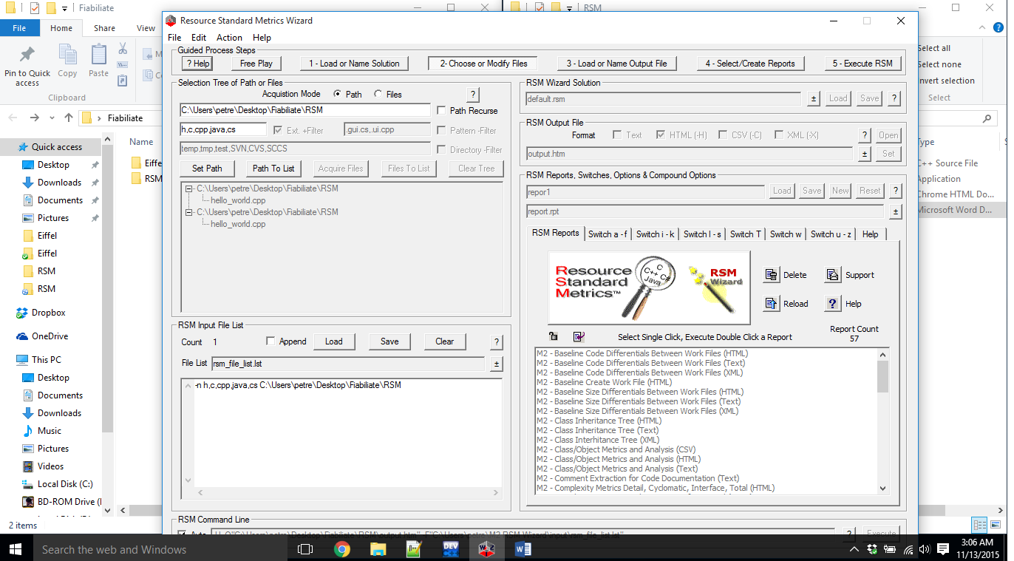

**Pasul 1. Load or Name Solution (Incarca sau alege o solutie)**

An RSM solution consists of a list of input files, an output file, and a report type. A solution can be loaded immediately and executed right away, after which you will receive the metrics report. All solutions have the *.rsm extension and can be found in the "solutions" directory.*

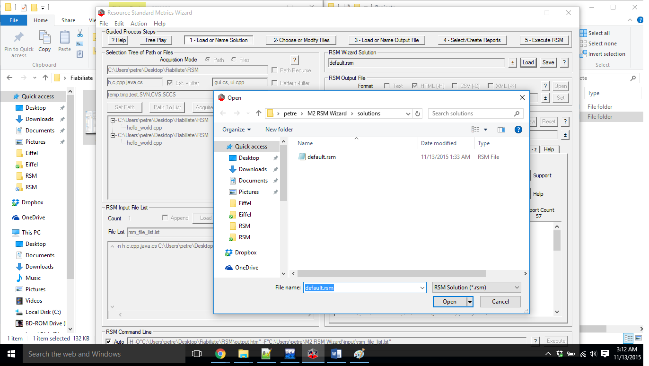

Codul unei solutii RSM:

*<?xml version="1.0" encoding="UTF-8"?>*

*<!-- RSM Solution File - Generated by the RSM Wizard -->*

*<Solution>*

*<Filename>C:\Users\petre\M2 RSM Wizard\solutions\default.rsm</Filename>*

*<ExecutionLine>-H -O"C:\Users\petre\M2 RSM Wizard\output\output.htm" -F"C:\Users\petre\M2 RSM Wizard\input\rsm_file_list.lst"</ExecutionLine>*

*<AutoFlag>1</AutoFlag>*

*<ProcessMode>0</ProcessMode>*

*<Input>*

*<InputMode>0</InputMode>*

*<InputPathName></InputPathName>*

*<InputRecursePathFlag>0</InputRecursePathFlag>*

*<InputExtFilter>h,c,cpp,java,cs</InputExtFilter>*

*<InputExtFilterFlag>1</InputExtFilterFlag>*

*<InputPatFilter>.gui.cs,.ui.cpp</InputPatFilter>*

*<InputPatFilterFlag>0</InputPatFilterFlag>*

*<InputDirFilter>temp,tmp,test,SVN,CVS,SCCS</InputDirFilter>*

*<InputDirFilterFlag>0</InputDirFilterFlag>*

*<InputFileName>C:\Users\petre\M2 RSM Wizard\input\rsm_file_list.lst</InputFileName>*

*</Input>*

*<OutputMode>1</OutputMode>*

*<OutputFileName>C:\Users\petre\M2 RSM Wizard\output\output.htm</OutputFileName>*

*<ReportFileName>C:\Users\petre\M2 RSM Wizard\reports\report.rpt</ReportFileName>*

*<ReportName>Report Name Not Set</ReportName>*

*</Solution>*

**Pasul 2. Choose or Modify Files (Alege sau modifica fisiere)**

In this step, you need to select the files that will be processed by the RSM tool. You can add a path for RSM to scan, or you can add a predefined list of files.

**Load or Name Input File List**

You can load a previous list or create a new one simply by naming it and saving it in step 2. This list is used by RSM as input data.

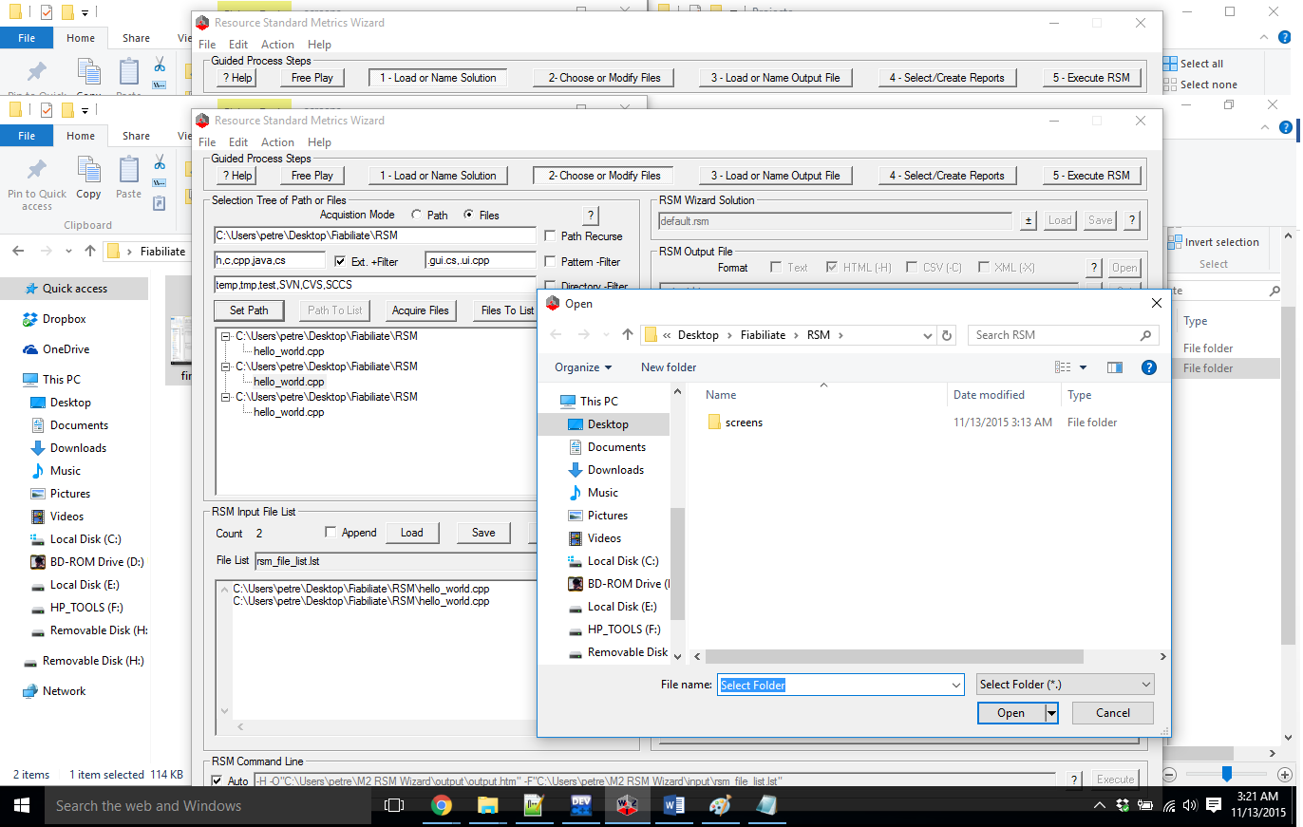

**Pasul 3. Load or Name Output File (Incarca sau numeste fisierul de iesire)**

This step allows you to specify the name of the report that will be generated. Normally, the output file will be in the current user's directory.

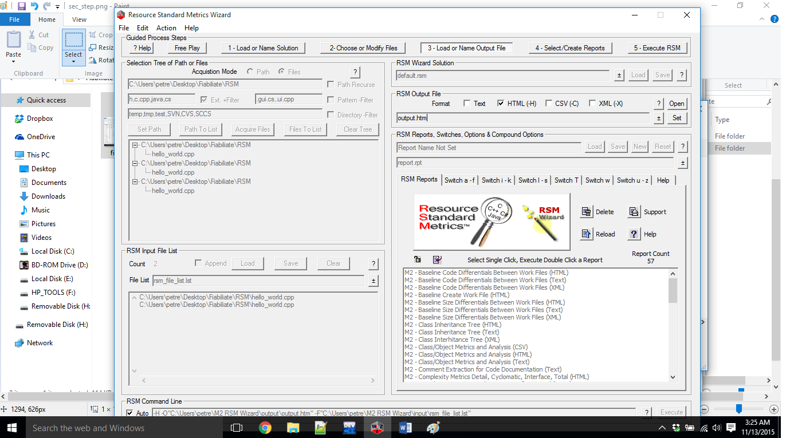

**Pasul 4. Select or Create Report (Selecteaza sau creeaza raport)**

RSM comes with several predefined reports. In this step, you simply choose the type of report, or you can create your own.

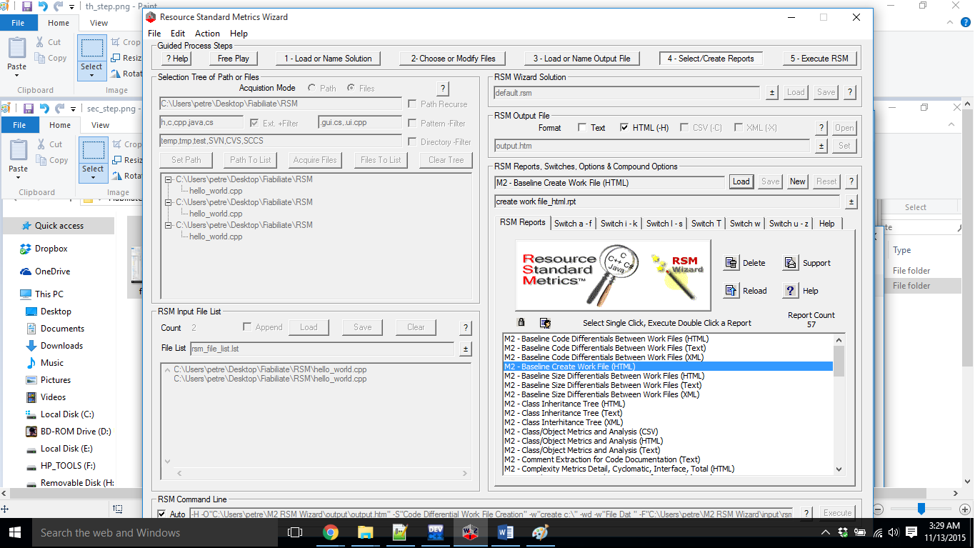

**Pasul 5: Execute (Executarea)**

You need to select Action, then Execute. The report will be processed and opened in the web browser, in a CSV file editor, or in a TXT file editor.

